

**The Institute of Applied Sciences**

**Fiji Ridge to Reef Project**

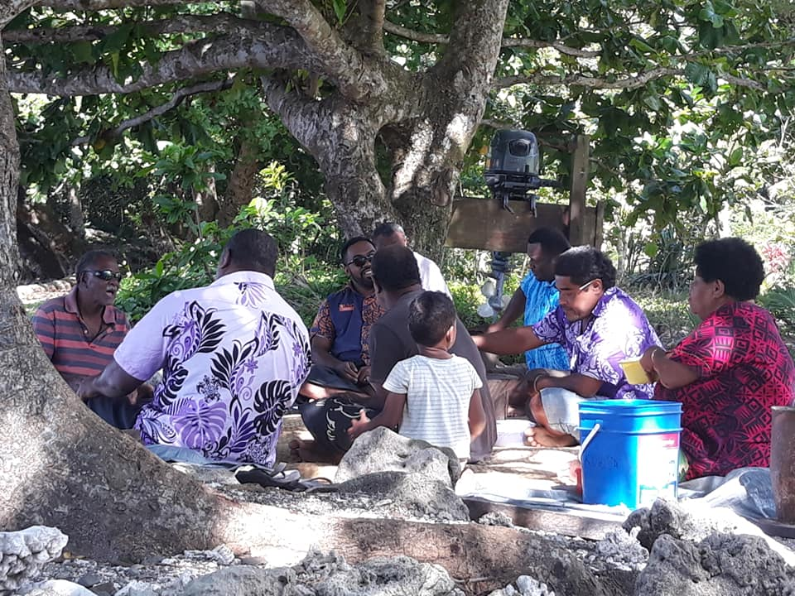**SUMMARY REPORT   
Reporting Period: 1 October to 31 December, 2019**

January 2020

This document was prepared by the Institute of Applied Sciences of the University of the South Pacific for the Fiji Ridge to Reef (R2R) Project. **This project is funded by the Global Environment Facility.**



**The Institute of Applied Sciences**

**Fiji Ridge to Reef Project**

**QUARTERLY REPORT   
Reporting Period: 1 October to 31 December, 2019**

Cover photo – ILK discussions at Navetau, Tunuloa with elders of the community.

Contents

List of Acronyms and Abbreviations 4

1. ACTIVITIES AND MILESTONES 5

1.1 Activity and Milestones 5

2. COMMUNICATIONS AND OUTREACH 8

2.1 Website and Social Media Platforms 9

2.2 Mainstream Media 9

2.3 Outreach 9

3. GENDER 9

3.1 Gender Plan 9

3.2 Activity Reports 9

4. ORGANIZATION CAPACITY 10

4.1. Internal Capacity Building 10

4.2. External Capacity Building 10

5. KEY ACHIEVEMENTS AND SUCCESSES 10

6. CHALLENGES FACED AND CORRECTIVE ACTIONS TAKEN 12

7. USP-IAS ACTIVITIES AND MILESTONES FOR QUARTER 1 2020 13

List of Acronyms and Abbreviations

|  |  |
| --- | --- |
|  |  |
| BOS | Bureau of Statistics |
| C3 | Community Centered Conservation |
| DFO | Divisional Fisheries/Forestry Officer |
| FELA | Fiji Environmental Law Association |
| FLMMA | Fiji Locally Managed Marine Areas (Network) |
| IAS | The Institute of Applied Sciences (USP) |
| IBA | Important Bird Area |
| IMR | The Institute of Marine Resources (USP) |
| LMMA | Locally Managed Marine Areas |
| LoA | Letter of Agreement |
| MACBIO | Marine and Coastal Biodiversity Management in Pacific Island Countries |
| MMA | Marine Managed Area |
| MOE-PMU | Ministry of Environment - Project Management Unit |
| MPA | Marine Protected Area |
| NFMV | Nature Fiji Mareqeti Viti |
| PCO | Provincial Conservation Officer |
| PSP | Permanent Sampling Plots |
| QMC | Quality, Marketing and Communications Unit (USP-IAS) |
| R2R | Ridge to Reef |
| SMS | School of Marine Studies (USP) |
| SPRH | South Pacific Regional Herbarium (USP-IAS) |
| UNDP | United Nations Development Program |
| USP | The University of the South Pacific |
| WWF | World Wildlife Fund |
|  |  |
|  |  |
|  |  |
|  |  |
|  |  |

# ACTIVITIES AND MILESTONES

*The sections below report on activities and milestones completed this quarter. Included in this quarter are financial status for each of the activities. Do note that the amounts could vary slightly because of variations in conversion from USD to FJD.*

## 1.1 Activity and Milestones

**Activity 1.1.1.2:** Ministry of Fisheries (R2R) support to *Vanua o Votua iqoliqoli* committee to review current community conservation action plan and marine protected areas (LMMA and tabu areas) connected with Ba River.

**USP-IAS sub-activity:** Marine biological surveys and CPUE to identify and delineate proposed community MMA’s.

Progress (ongoing): Fieldwork for this Activity has been completed. The CPUE Census report will now be submitted in Quarter 1 2020.

Milestone: None for the quarter.

Total Budget: USD 57,590

Quarter 4 expenses: USD 3,352.07

Accumulative expenses: USD 57,502.22

**Activity 1.1.1.3:** Ba River (freshwater) qoliqoli to develop management plan and implement and lobby for required actions and practices to restore freshwater fisheries (including especially prawn, kai and finfish).

**USP-IAS sub-activity:** Freshwater baseline survey with three specific indicators – species, water quality and sedimentation.

Progress (ongoing): Fieldwork for this Activity was completed as of Quarter 3 2019. The Ba Freshwater Survey and the Mangrove Nekton reports have been submitted. The Ba River Water Quality and Sedimentation report will be submitted in Quarter 1 2020.

Milestones: Ba Freshwater Survey and Mangrove Nekton Reports.

Total Budget: USD 125,540

Quarter 4 expenses: USD 2,300

Accumulative expenses: USD 125,631.85

**Activity 1.1.1.4:** Ministry of Fisheries (R2R) support to Macuata Cokovata *qoliqoli* committee and *qoliqoli* owners of Vanua Labasa and Wailevu to develop/review /confirm better plan location of MPA (LMMA & tabu areas) connected with Labasa River.

**USP-IAS sub-activity:** Marine biological survey and CPUE to identify and delineate proposed community MMA’s.

Progress (ongoing): Fieldwork for this Activity has been completed. The Shark and Ray report was submitted while the CPUE Report will be submitted in Quarter 1 2020.

Milestone: Shark and Ray Rapid Assessment Report.

Total Budget: USD 78,590

Quarter 4 expenses: USD 25,215.75

Accumulative expenses: USD 77,535.62

**Activity 1.1.1.5:** Labasa River (freshwater) qoliqoli to develop management plan and implement and lobby for required actions and practices to restore freshwater fisheries (including especially prawn, kai and finfish).

**USP-IAS sub-activity:** Freshwater baseline survey with three specific indicators – species, water quality and sedimentation.

Progress (ongoing): The Labasa Freshwater Survey, Labasa River Water Quality and Sedimentation and the Mangrove Nekton reports will be submitted in Quarter 1 2020.

Milestones: None for the quarter.

Total Budget: USD 107,235

Quarter 4 expenses: USD 49,250

Accumulative expenses: USD 92,280

**Activity 1.1.1.7:** Undertake negotiations with eleven *mataqali’s* involving NFMV, R2R/DoE, TLTB, TAB and NTF, to confirm interest to formalize existing terrestrial Protected Area in Tunuloa catchment (Year 1).

Progress (ongoing): The mataqali consultation outcomes will be returned to the mataqali’s. USP-IAS will carry this out in February 2020.

Milestone: None for the quarter.

Total Budget: USD 54,830

Quarter 4 expenses: Nil

Accumulative expenses: USD 48,606.58

**Activity 1.1.2.11:** Comprehensive BIORAP survey of site for a new Tuva PA (located in upper Tuva catchment and adjacent part of upper Nadi catchment, Vunamoli mataqali), to be conducted by USP IAS in Year 1.

Progress (ongoing): The final reports were submitted in Quarter 4 2019.

Milestone: Tuva BioRap Report.

Total Budget: USD 157,410

Quarter 4 expenses: USD 15,200

Accumulative expenses: USD 145,162.45

**Activity 2.1.1.14:** Identify areas in need of reforestation notably wastelands of African tulip and degraded open secondary forests: this activity to be undertaken through collaboration of DoF and landowners in Year 1.

Progress (completed): This Activity has been completed.

Milestone: African tulip wasteland report submitted.

Total Budget: USD 42,700

Quarter 4 expenses: Nil

Accumulative expenses: USD 42,711.52

**Activity 2.1.1.19:** Undertake once-off stand improvement activities in secondary forests (at a rate of 50 ha per year in Years 2, 3 and 4), including removal/cutting of African tulip and cutting of overtopping vines – wadamu (*Merremia peltata*). The selected forests will be those which are in reasonably good condition and preferably located in buffer zones for Sovi Basin Protected Area (within 5-10 km), with the stand improvement to be undertaken by Nadakuni villagers.

Progress (continuation): Coordination meetings with the National Trust of Fiji and the Ministry of Forests will need to be convened as the Ministry of Forests underwent an internal reorganization in Quarter 4 2019. The NTF and USP-IAS carried out community awareness in the communities surrounding the Sovi Basin buffer zone and now await coordination with the Ministry of Forests to move forward with an inventory.

Milestone: Community consultations completed.

Total Budget: USD 195,750

Quarter 4 expenses: USD 10,642.49

Accumulative expenses: USD 10,642.49

**Activity 2.1.1.21:** Establish 10 ha of mangrove demonstration stands per year in years 2, 3 and 4.

Progress (ongoing): The USP-IAS team continued with seedling stocking and planting during the quarter. The breakdown of these are as per table below:

|  |  |  |  |  |  |
| --- | --- | --- | --- | --- | --- |
| **Description** | **Species** | **Local Names** | **Seedlings obtained** | **Seedlings planted** | **Area planted** |
| Coastal & native trees | *Gonystylus punctatua* | Mavota | 30 | 30 | 7.55 ha |
| *Dacrycarpus imbricatus* | Amunu | 24 | 24 |
| *Myristica* spp. | Kaudamu | 135 | 135 |
| *Aleurites moluccana* | Lauci | 150 | 150 |
| *Palaquim vitilevuensis* | Bau | 41 | 41 |
| *Tahitian chestnut* | Ivi | 72 | 72 |
| *Garcinia myrtifolia* | Laubu | 10 | 10 |
| *Myristica* spp. | Kaudamu (tbc) | 60 | 60 |
| *Endospermum macrophyllum* | Kauvula | 110 | 110 |
| *Cocos nucifera* | Niu | 1175 | 1175 |
| Mangrove | *Rhizophora* spp. | Tiri | 6044 | 6044 | 3.01 |
| **Total** | |  | **7,851** | **7,851** | **10.56 ha** |

Milestone: ~10.5 ha of area planted in 2019.

Total Budget: USD 102,700

Quarter 4 expenses: USD 9,330

Accumulative expenses: USD 46,843.22

**Activity 2.2.3.4:** DoF in association with research partners (including Southern Cross University/ACIAR, SPC) establish sample plots, annually measure and reports on growth, survival and carbon sequestration in reforestation plantings of enrichment plantings, and impact of stand improvement activities.

**USP-IAS Sites:** Tuva and Waidina

Progress (ongoing): USP-IAS is seeking permission from UNDP and the Ministry of Environment to test the methodology in Nakavu, Namosi before establishing the sampling plots in Tuva and Waidina respectively. The test is to establish if the developed methodology will return the same results for parameters measured by the Ministry of Forests, especially as the suggested new methodology has two extra parameters, soil and leaf litter measurements, to add to the data already collected. The tested methodology will add two extra parameters to existing carbon stocks. With approval we intend to carry out this test in late February through the March, 2020.

Milestone: None for the quarter.

Total Budget: USD 207,300

Quarter 4 expenses: USD Nil

Accumulative expenses: USD 55,406.66

**Activity 3.1.1.2:** Demographic and socioeconomic data for the R2R catchments reviewed and refined by Ministry of Strategic Planning/ Bureau of Statistics as input into catchment management plans – (2nd Quarter, Year 1).

**USP-IAS Sites:** Tuva, Waidina-Rewa, Vunivia and Tunuloa

Progress (ongoing): This activity has been completed and all reports sent in. Do note that the amount budgeted has been exhausted for this activity and additional expenses of USD 19,791 has been submitted as in-kind contribution to the R2R Project.

Milestone: Activity completed.

Total Budget: USD 24,900

Quarter 4 expenses: USD Nil

Accumulative expenses: USD 44,691.00

**Activity 3.1.1.3:** Survey outcomes and biophysical and demographic studies is made available to communities /stakeholders for information and to assist with formulation of management plans (Year 1)

**USP-IAS Sites:** Tuva, Waidina-Rewa, Vunivia and Tunuloa

Progress (ongoing): The Vunivia and Tunuloa catchment surveys were conducted from October to November 2019. A team of eight enumerators from USP-IAS were trained and visited villages and settlements over three weeks. This survey included TEK studies in selected sites in each of the catchments. The Vunivia report was submitted in December 2019 while the Tunuloa report, along with the two TEK reports, will be submitted in Quarter 1 2020.

Milestone: Vunivia and Tunuloa surveys completed. Vunivia report submitted.

Total Budget: USD 210,200

Quarter 4 expenses: USD 102,178

Accumulative expenses: USD 202,058.20

# COMMUNICATIONS AND OUTREACH

*These are the communication and outreach activities conducted over the reporting period.*

## 2.1 Website and Social Media Platforms

* 1. USP-IAS’s Facebook page continues to highlight our on-ground activities. Some posts have been shared by UNDP onto their page and we are getting positive feedback with increasing views on these posts. We continue to acknowledge the funding by GEF and UNDP and the Fijian Government through the Ministry of Environment as implementers.

## 2.2 Mainstream Media

1. There were no outreach to mainstream media in the Quarter.

## 2.3 Outreach

Progress (ongoing): There was one joint outreach program organized in coordination with the MOE-PMU and various Government Ministries. This was the Vunivia and Tunuloa socioeconomic and TEK surveys. Partnering organizations involved in this were the UNDP/MOE PMU team and the Macuata and Cakaudrove Provincial Offices.

# GENDER

*Activities conducted to address issues identified in our Gender Analysis and Gender Action Plan include the activities, location, audience, outcomes and next steps where appropriate.*

## 3.1 Gender Plan

Over the duration of the quarter, women and youth were engaged and participated in community consultations and fieldwork.

## 3.2 Activity Reports

**Activity 1.1.1.5**

Progress (ongoing): Bindiya Rashni is engaged as lead freshwater scientist on this survey.

**Activity 2.1.1.21**

Progress (ongoing): The mangrove rehabilitation activities in Nukui, Rewa and Nakalawaca, Tailevu continues to include females from their youth group. Our team collaborates closely with Raijieli Kolinisau and Talei Kocovanua, the PCO’s Rewa and Tailevu respectively.

**Activity 3.1.1.3**

Progress (ongoing): Women and youth were interviewed during the surveys in Vunivia and Tunuloa.

# ORGANIZATION CAPACITY

## Internal Capacity Building

*USP-IAS conducted the following activities to address its organization’s internal capacity and included initiatives towards enhancing USP-IAS’s financial, managerial, administrative and technical implementation capacity.*

Progress (ongoing): The USP-IAS project technical leads continually monitor implementation and modifies its internal structures to meet its contractual obligations. This quarter we engaged a consultant to review BioRap reports and to provide peer reviewed feedback and direction on it.

## External Capacity Building

Progress (ongoing): The USP-IAS obligation to build the capacity of Government partners over the duration of this Fiji R2R Project was partially achieved over this quarter as follows:

* The UNDP/MOE PMU team and Macuata and Cakaudrove Provincial Office Conservation Officers were engaged and received on-site training on the socioeconomic and TEK survey questionnaires. They were encouraged to lead some of the discussions.

# KEY ACHIEVEMENTS AND SUCCESSES

*Quarterly selection of our top two achievements or successes including a description of the activity and people in the photo as well as information on who took the photo.*

**Activity 2.1.1.21:** The Nakalawaca Youth continued with *Rhizophora* seedling propagation after the first round of *Rhizophora* seedlings were transplanted. The fact that the youth were able to organize this on their own ensures the sustainability of the R2R project in the district.

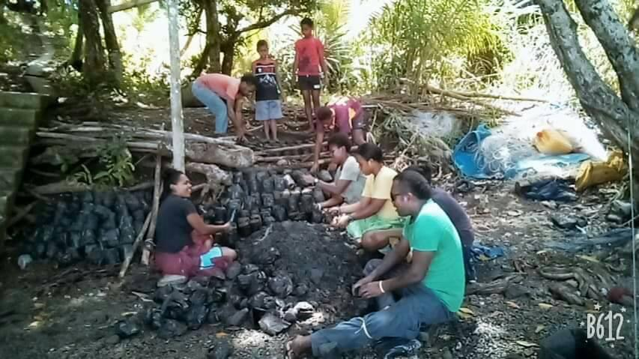

The Nakalawaca youth potting bags of soil for *Rhizophora* seedlings in November 2019.

**Photo Credit:** Margret Tarah, Nakalawaca

**Activity 3.1.1.3:** A team from USP-IAS conducted the Vunivia and Tunuloa socioeconomic and TEK surveys from October to November 2019. These surveys were conducted in around 90% of the communities within these catchments ensuring detailed data and knowledge were captured.

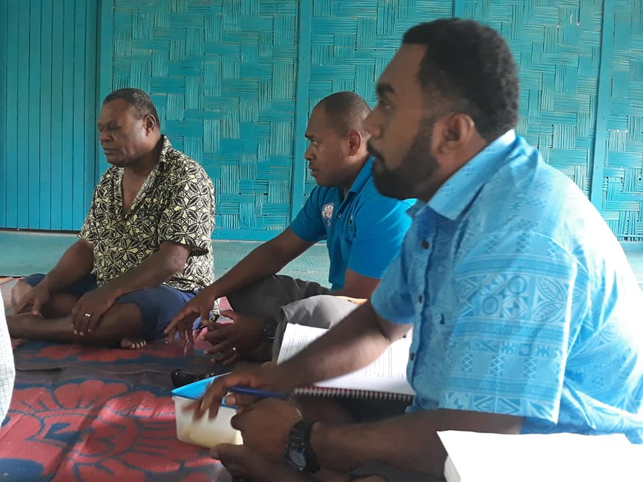

The Mata ni Tikina Tunuloa (left), Lote Rusaqoli (PMU North Coordinator (middle)) and Tuverea Tuamoto (USP-IAS (right)) carry out TEK questionnaires in one of the communities in Tunuloa.

**Photo Credit:** IAS, USP

# CHALLENGES FACED AND CORRECTIVE ACTIONS TAKEN

*Challenges or difficulties encountered this quarter, like severe weather, lack of interest on stakeholder or beneficiaries’ part, etc., and what USP-IAS has done/is doing to address the issue.*

Challenge 1: A reorganization of personnel within the Ministry of Forests put on hold plans for the quarter. This affected Activities 2.1.1.19 and 2.2.3.4.

Recommendation: We have since reengaged discussions with the Ministry of Forests and are very pleased with the outcomes. The Executive Director has been very helpful as well as the Divisional Directors. We are optimistic that Quarter 4 2019 plans will eventuate in Quarter 1 2020.

# USP-IAS ACTIVITIES AND MILESTONES FOR QUARTER 1 2020

*Planned activities for Quarter 1 2020 are listed here including those that will begin and continuing ones from the previous quarter.*

**Activity 1.1.1.2 (continuation):** The fieldwork associated with this activity has been completed. The only pending report is the CPUE Survey and this will be submitted this quarter.

Milestone: CPUE Survey Report

Budget Request: Nil

**Activity 1.1.1.3 (continuation):** The Ba River freshwater mussel survey and Ba River water quality and sedimentation reports that were initially planned for Quarter 4 2019 will now be submitted in Quarter 1 2020. Due to the large amounts of freshwater mussel data collected analysis took longer than anticipated. This led to the delay. Concerning the water quality and sedimentation analysis and report, the pesticides lab analysis had to be postponed due to a breakdown in the relevant machine. Pesticides is an important parameter in the quality of water for any river system.

Milestone: Ba River freshwater mussel and Ba River water quality and sedimentation report

Budget Request: Nil

**Activity 1.1.1.4 (continuation):** The fieldwork associated with this activity has been completed. The only pending report is the CPUE Survey and this will be submitted this quarter.

Milestone: CPUE Survey Report

Budget Request: Nil

**Activity 1.1.1.5 (continuation):** The Labasa mangrove nekton survey, Labasa River invertebrate and vertebrate survey and Labasa River water quality and sedimentation reports will be completed in Quarter 1 2020. The above reports have been drafted and will be submitted for lead scientist review before they are submitted. The freshwater vertebrate replicate survey and freshwater mussel survey will be carried out this quarter also.

Milestone: Completion of Labasa mangrove nekton survey, Labasa River invertebrate and vertebrate survey and Labasa River water quality and sedimentation reports.

Budget Request: Nil

**Activity 1.1.1.7 (continuation):** The consultations with the eleven mataqali’s in Natewa-Tunuloa has been completed. The USP-IAS team will return to present the results of the consultations to all mataqali’s in Q1 2020. This was delayed from Quarter 4 2019 due to the same staff being engaged with the socioeconomic and TEK surveys.

Milestone: Workshop Report

Budget Request: Nil

**Activity 1.1.2.11 (continuation):** Awaiting the return of review of the BioRap report before we close off this activity.

Milestone: Nil

Budget Request: Nil

**Activity 1.1.2.7 (begin):** The Tunuloa BioRap recon and fieldwork is being earmarked for Quarter 1 2020.

Milestone: Recon and field activities to begin

Budget Request: USD 153,540

**Activity 2.1.1.19 (continuation):** USP-IAS has had to reengage with the Ministry of Forests Director Central/Eastern and the National Trust of Fiji. It was agreed that the inventory of the Sovi Basin buffer zone can be carried out in Quarter 1 2020.

Milestone: Commencement of the Sovi Basin buffer zone inventory

Budget Request: Nil

**Activity 2.1.1.21 (continuation):** USP-IAS will continue with the stocking of seedlings at the Ministry of Forests distribution nurseries in the two provinces and the potting and transplanting of *Rhizophora* seedlings in Nukui, Rewa and Nakalawaca, Tailevu.

Milestone: Seedlings (fruit, native and *Rhizophora* seedlings) stocked.

Budget Request: Nil

**Activity 2.2.3.4 (Tuva) (continuation):** A comparative study is being suggested for Nakavu, Namosi where the Ministry of Forests has established a Permanent Sampling Plot (PSP) with data collected. The comparative study is to test the R2R methodology, which assesses at least two parameters more than what the Ministry of Forests methodology assesses. A joint meeting between USP-IAS and the Ministry of Forests agreed that it would be critical first to establish if the R2R methodology will return the same results as the PSP for the same parameters. Hence, Nakavu, Namosi was agreed to before USP-IAS and the Ministry of Forests set up sampling plots in Tuva and Waidina. USP-IAS along with the Ministry of Forests will submit a request to UNDP for the test to begin and baseline assessments for an established sample plot in Tuva to be carried out this Quarter.

Milestone: R2R Methodology tested.

Budget Request: Nil

**Activity 2.2.3.4 (Waidina) (continuation):** As above.

Milestone: R2R Methodology tested.

Budget Request: Nil

**Activity 3.1.1.3 (continuation):** Fieldwork for this activity has been completed. The Tunuloa demographic, socio-economic, and biophysical survey report will be submitted this quarter along with the TEK survey reports for Vunivia and Tunuloa.

Milestone: Tunuloa socioeconomic and the Vunivia and Tunuloa TEK reports.

Budget Request: Nil

**TOTAL AMOUNT REQUESTED FOR TRANCHE 5 TRANSFER = USD 153,540**